House Price Prediction using Machine Learning Regression Models (Linear, Ridge, Random Forest and Gradient Boosting)
Problem Statement:
Buying or selling a house is one of the most important financial decisions in a person’s life, yet the market value of a property depends on many interacting factors such as its location, living area, lot size, number of bedrooms and bathrooms, construction quality, year built and the amenities it offers. Traditional valuation relies on manual appraisal and a limited set of comparable sales, which is slow, subjective and often inconsistent between different appraisers.
There is, therefore, a need for an automated, fast and data-driven system that can estimate the market price of a house from its attributes, along with a realistic price range, so that buyers, sellers and agents can make informed decisions. This project designs and implements a Machine Learning pipeline for house price prediction that performs exploratory data analysis, feature engineering and preprocessing, trains and compares four regression models (Linear Regression, Ridge Regression, Random Forest and Gradient Boosting), evaluates them using standard regression metrics (R², MAE, RMSE), and exports the best model to a web-based valuation engine (PropValuate AI).
Objectives:
- To load and explore a housing dataset using Exploratory Data Analysis (price distribution and price versus square footage by neighbourhood).
- To select the relevant features (sqft, bedrooms, bathrooms, quality, yearBuilt, garage, pool, waterfront and neighborhood) and encode the categorical neighbourhood variable.
- To split the data into training and testing sets and train Linear Regression, Ridge Regression, Random Forest and Gradient Boosting regressors.
- To evaluate and compare the models using R², Mean Absolute Error (MAE) and Root Mean Squared Error (RMSE).
- To analyse the Random Forest feature importance and save the trained model (best_housing_model.pkl) using joblib.
- To use the exported model in a web valuation engine that shows the estimated market value, price range, value breakdown and estimated monthly payment for any property.
Introduction:
Machine Learning (ML) is a branch of Artificial Intelligence in which a computer learns patterns from historical data and uses them to make predictions on new, unseen data. When the value to be predicted is a continuous number — such as the price of a house — the task is known as regression. House price prediction is one of the most popular real-world applications of regression, because the price of a property is influenced by many measurable attributes and a trained model can capture their combined effect far better than a simple rule of thumb.
In this project a housing dataset is analysed, the relevant attributes are selected and encoded, and four regression algorithms are trained and compared. The best-performing model is saved and integrated into PropValuate AI, a web-based valuation engine in which the user adjusts the property attributes and instantly receives an estimated market value, a price range, the price per square foot, a breakdown of what contributes to the value and an estimated monthly mortgage payment.
Software / Hardware Required:
• Operating System: Windows / Linux / macOS
• IDE: Jupyter Notebook
• Language: Python 3.x
• Machine Learning: scikit-learn (LinearRegression, Ridge, RandomForestRegressor, GradientBoostingRegressor)
• Data Handling: pandas, NumPy
• Visualization: Matplotlib, Seaborn
• Model Persistence: joblib
• Frontend: PropValuate AI web valuation engine (HTML5, CSS3, JavaScript)
• Dataset: housing_dataset.csv (Metro Area Housing – King County / Seattle model, 115 homes)

Dataset Description:
The dataset (housing_dataset.csv) contains the details of 115 homes from the metro-area housing market (King County / Seattle model) with a median market price of $761,000 and an average price of $364 per sq. ft. Each record describes one house using the attributes listed below; price is the target variable that the models learn to predict.
Feature | Description | Type
sqft | Living area of the house in square feet | Numeric
bedrooms | Number of bedrooms | Numeric
bathrooms | Number of bathrooms (e.g. 2, 2.5, 3) | Numeric
quality | Overall construction quality grade (1–10 scale) | Numeric
yearBuilt | Year in which the house was built | Numeric
garage | Garage availability (amenity) | Numeric / Binary
pool | Swimming pool availability (amenity) | Numeric / Binary
waterfront | Waterfront view availability (amenity) | Numeric / Binary
neighborhood | Neighbourhood / area of the house (one-hot encoded) | Categorical
price | Market price of the house in US dollars (target) | Numeric (Target)

Machine Learning Models Used:
1. Linear Regression — fits a straight-line (linear) relationship between the input features and the price by minimising the sum of squared errors. It is simple, fast and easy to interpret, and is used as the baseline model.
2. Ridge Regression (alpha = 1.0) — an extension of linear regression that adds an L2 penalty on the size of the coefficients. This regularisation reduces over-fitting and keeps the model stable when features are correlated.
3. Random Forest Regressor (100 trees) — an ensemble of 100 decision trees, each trained on a random sample of the data and features. The final price is the average of all the trees, which captures non-linear relationships and gives a feature-importance score. This model is saved as the final model.
4. Gradient Boosting Regressor (100 estimators) — builds decision trees one after another, where each new tree corrects the errors made by the previous trees. It is powerful for tabular data but is more sensitive to its settings than a random forest.
Model Parameters Used:
Model | Parameters
Linear Regression | Default parameters
Ridge Regression | alpha = 1.0
Random Forest Regressor | n_estimators = 100, random_state = 42
Gradient Boosting Regressor | n_estimators = 100, random_state = 42
Train / Test Split | test_size = 0.2 (80% training, 20% testing), random_state = 42
Table 1: Parameters used for training the regression models
Evaluation Metrics:
The models are compared on the 20% test set using three standard regression metrics, where y is the actual price, ŷ is the predicted price and n is the number of test samples:
• Mean Absolute Error (MAE) = (1/n) Σ |y − ŷ| — the average size of the prediction error in dollars; lower is better.
• Root Mean Squared Error (RMSE) = √[(1/n) Σ (y − ŷ)²] — similar to MAE but penalises large errors more heavily; lower is better.
• R² Score = 1 − [Σ (y − ŷ)² / Σ (y − ȳ)²] — the proportion of the variation in price explained by the model; closer to 1 is better.

System Workflow:
The overall workflow of the project is shown in Fig 1. The raw housing data is first explored and cleaned, the selected features are encoded, and the data is divided into training and testing sets. Four regression models are then trained and evaluated, and the best model is saved and loaded into the PropValuate AI web application, where it produces the valuation for the attributes entered by the user.
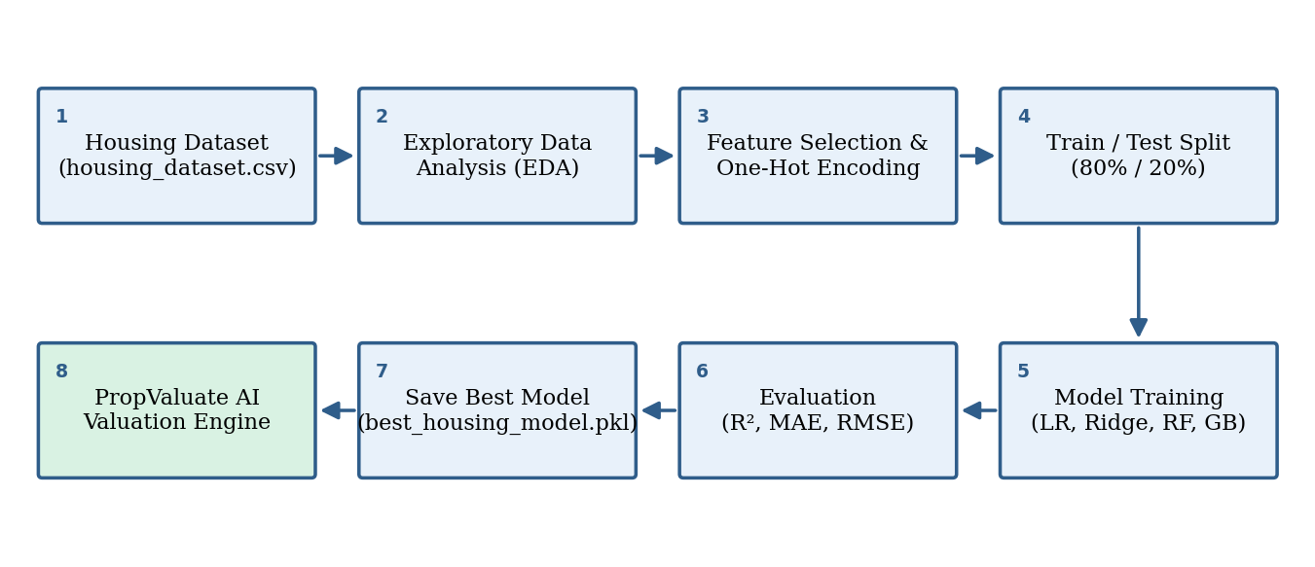
Fig 1: Workflow of the House Price Prediction system
Exploratory Data Analysis and Feature Importance:
Exploratory Data Analysis (EDA) is performed before training to understand the data. The df.info() and df.describe() commands give the data types, the number of records and the statistical summary of every column. The price distribution histogram (with a KDE curve) shows how the house prices are spread, and the scatter plot of price versus square footage, coloured by neighbourhood, shows that larger houses and certain neighbourhoods have higher prices.
After training, the feature_importances_ attribute of the Random Forest model is plotted as a bar chart. It ranks every input feature by its relative contribution to the prediction, which helps to understand which attributes (such as living area, quality and neighbourhood) influence the price the most and supports the value breakdown shown in the web application.

Project Directory Structure:
The project (“HousePricePrediction”) consists of the dataset, the Jupyter notebook that trains and evaluates the models, the exported model file, and the web valuation engine, as shown below.
HousePricePrediction/
|-- housing_dataset.csv # dataset
|-- House_Price_Prediction.ipynb # training notebook
|-- best_housing_model.pkl # saved model (joblib)
`-- PropValuate AI (web app) # valuation engine

Procedure:
1. Collect the housing dataset (housing_dataset.csv) and load it into a pandas DataFrame using pd.read_csv(); print the shape of the data.
2. Perform Exploratory Data Analysis — df.info(), df.describe(), the price distribution histogram and the price vs. square footage scatter plot coloured by neighbourhood.
3. Select the features (sqft, bedrooms, bathrooms, quality, yearBuilt, garage, pool, waterfront) and one-hot encode the neighborhood column using pd.get_dummies(drop_first=True); set price as the target.
4. Split the data into 80% training and 20% testing sets using train_test_split (test_size=0.2, random_state=42).
5. Train four regression models — Linear Regression, Ridge Regression (alpha=1.0), Random Forest (100 trees) and Gradient Boosting (100 estimators).
6. Predict on the test set and compute MAE, RMSE and R² for each model; collect the results in a comparison table.
7. Plot the Random Forest feature importance to identify the attributes that influence the house price the most.
8. Save the Random Forest model as best_housing_model.pkl using joblib.dump() for use in the web valuation engine.
9. Open the PropValuate AI web application and enter the property attributes — neighbourhood, living area, lot size, year built, bedrooms, bathrooms, quality rating and amenities.
10. Click Re-estimate Valuation to obtain the estimated market value with its price range, price per sq. ft., value breakdown and estimated monthly payment, and compare the valuations for different bedroom and bathroom combinations.

Implementation Code:
Implementation of the key stages of the project, taken from the House_Price_Prediction.ipynb notebook.
1. Importing Libraries (House_Price_Prediction.ipynb)
import pandas as pd
import numpy as np
import matplotlib.pyplot as plt
import seaborn as sns

from sklearn.model_selection import train_test_split
from sklearn.linear_model import LinearRegression, Ridge, Lasso
from sklearn.ensemble import RandomForestRegressor, GradientBoostingRegressor
from sklearn.metrics import mean_absolute_error, mean_squared_error, r2_score
import joblib

# Set style
sns.set_theme(style="whitegrid")
plt.rcParams['figure.figsize'] = (10, 6)
2. Loading the Dataset and Exploratory Data Analysis
df = pd.read_csv('housing_dataset.csv')
print("Shape:", df.shape)
df.head()

df.info()
df.describe()

# Price Distribution
plt.figure(figsize=(10, 5))
sns.histplot(df['price'], kde=True, color='teal')
plt.title('Distribution of House Prices')
plt.xlabel('Price ($)')
plt.ylabel('Count')
plt.show()

# Price vs Square Footage
plt.figure(figsize=(10, 6))
sns.scatterplot(data=df, x='sqft', y='price', hue='neighborhood', s=100, alpha=0.8)
plt.title('Price vs. Square Footage by Neighborhood')
plt.xlabel('Square Footage')
plt.ylabel('Price ($)')
plt.show()
3. Data Preprocessing and Feature Selection
features = ['sqft', 'bedrooms', 'bathrooms', 'quality', 'yearBuilt', 'garage', 'pool', 'waterfront']
X = pd.get_dummies(df[features + ['neighborhood']], drop_first=True)
y = df['price']

X_train, X_test, y_train, y_test = train_test_split(X, y, test_size=0.2, random_state=42)
print(f"Train size: {X_train.shape[0]}, Test size: {X_test.shape[0]}")
4. Model Training and Comparison
models = {
'Linear Regression': LinearRegression(),
'Ridge Regression': Ridge(alpha=1.0),
'Random Forest': RandomForestRegressor(n_estimators=100, random_state=42),
'Gradient Boosting': GradientBoostingRegressor(n_estimators=100, random_state=42)
}

results = []
for name, model in models.items():
model.fit(X_train, y_train)
preds = model.predict(X_test)
mae = mean_absolute_error(y_test, preds)
rmse = np.sqrt(mean_squared_error(y_test, preds))
r2 = r2_score(y_test, preds)
results.append({'Model': name, 'MAE': mae, 'RMSE': rmse, 'R²': r2})

results_df = pd.DataFrame(results)
results_df
5. Feature Importance and Saving the Model
rf = models['Random Forest']
importances = pd.Series(rf.feature_importances_, index=X_train.columns).sort_values(ascending=False)

plt.figure(figsize=(10, 6))
sns.barplot(x=importances.values, y=importances.index, palette='viridis')
plt.title('Random Forest Feature Importance')
plt.xlabel('Relative Importance')
plt.show()

joblib.dump(rf, 'best_housing_model.pkl')
print("Model saved successfully as best_housing_model.pkl")
Code Explanation:
The libraries are imported first, and the dataset is loaded and explored with pandas, Matplotlib and Seaborn. The selected features are converted into model inputs (neighborhood is one-hot encoded) and split 80:20 into training and testing sets. The four models are trained in a loop and compared using MAE, RMSE and R², and the Random Forest model is saved with joblib for the web valuation engine.
Output (Step-by-Step Screenshots):
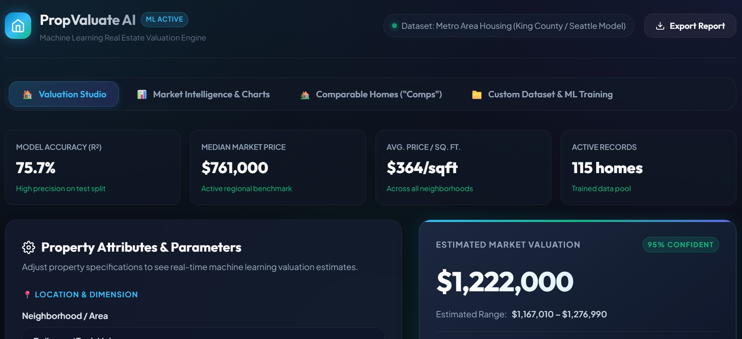
Fig 2: Step 1 — PropValuate AI dashboard: model accuracy (R² 75.7%), median market price ($761,000), average price per sq. ft. ($364) and 115 active records, with the default estimated valuation of $1,222,000
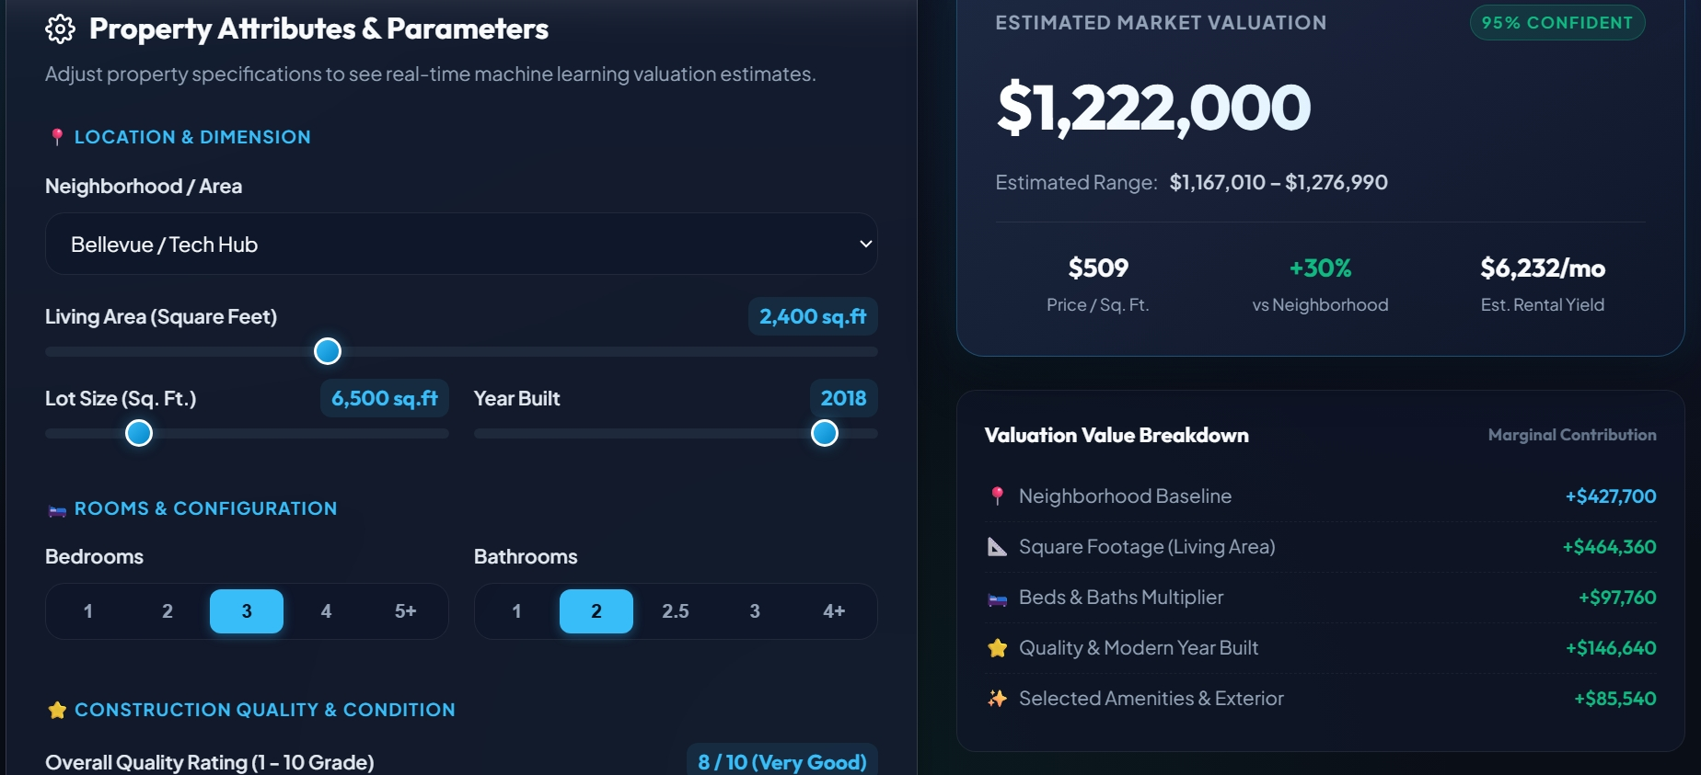
Fig 3: Step 2 — Property attributes input (Bellevue / Tech Hub, 2,400 sq. ft., 6,500 sq. ft. lot, built 2018, 3 bedrooms, 2 bathrooms, quality 8/10) and the valuation value breakdown
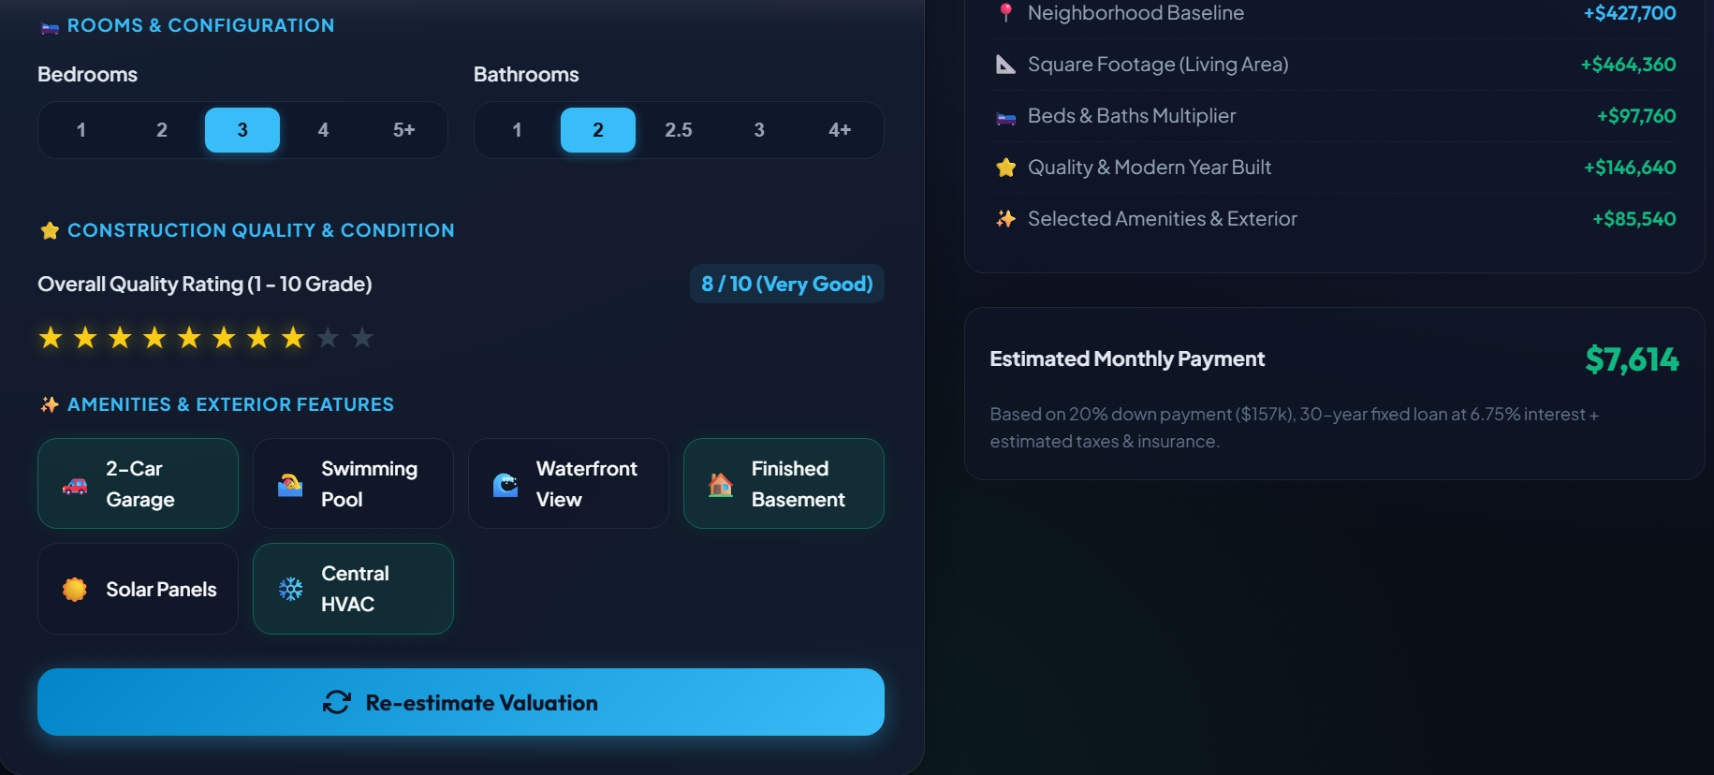
Fig 4: Step 2 — Construction quality rating, amenities & exterior features, Re-estimate Valuation button and the estimated monthly payment ($7,614)
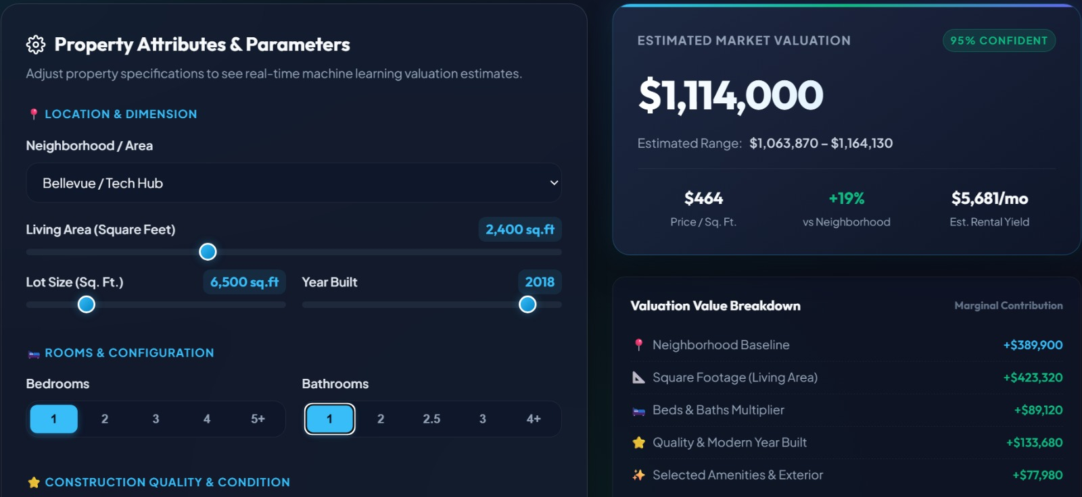
Fig 5: Step 3 — Prediction for 1 bedroom and 1 bathroom: estimated market valuation $1,114,000 (range $1,063,870 – $1,164,130)
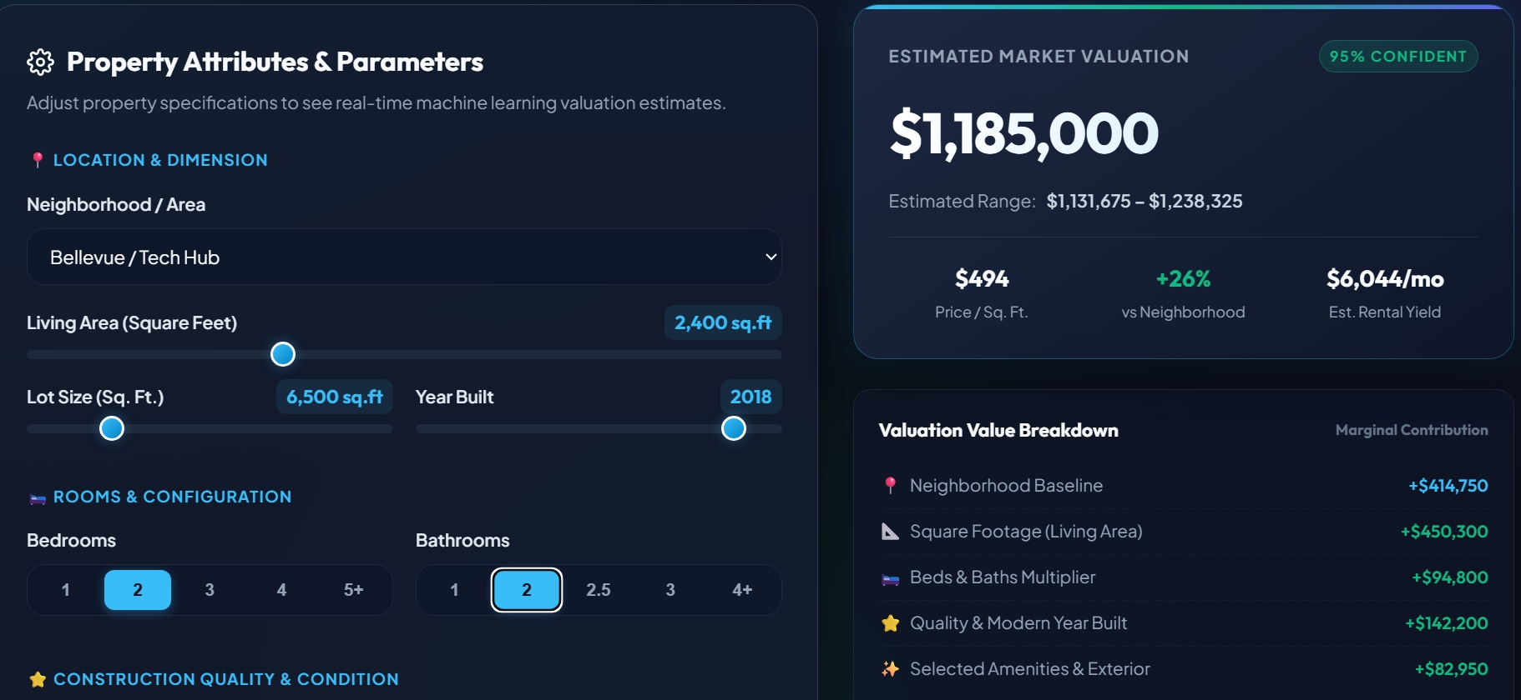
Fig 6: Step 3 — Prediction for 2 bedrooms and 2 bathrooms: estimated market valuation $1,185,000 (range $1,131,675 – $1,238,325)
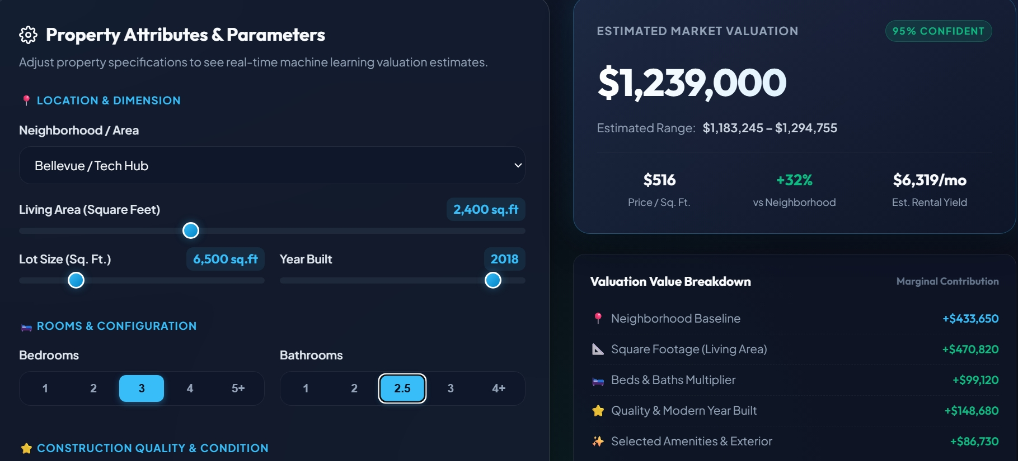
Fig 7: Step 3 — Prediction for 3 bedrooms and 2.5 bathrooms: estimated market valuation $1,239,000 (range $1,183,245 – $1,294,755)
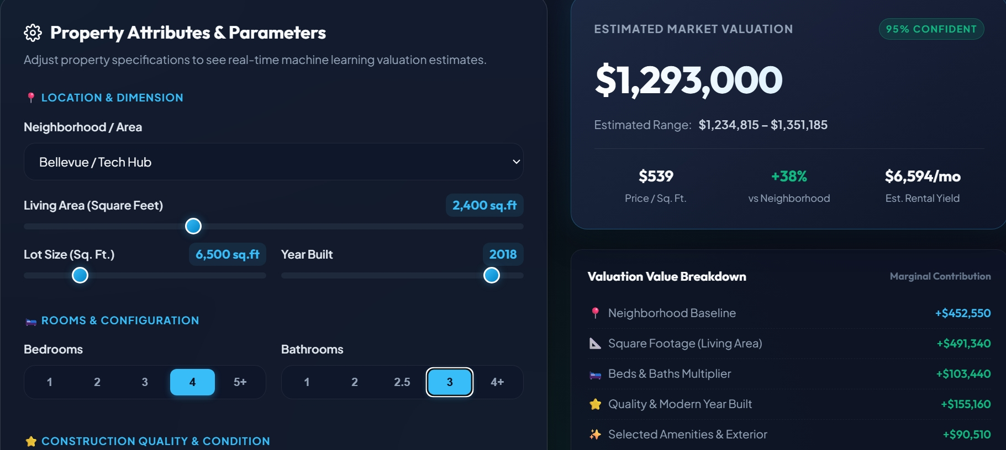
Fig 8: Step 3 — Prediction for 4 bedrooms and 3 bathrooms: estimated market valuation $1,293,000 (range $1,234,815 – $1,351,185)
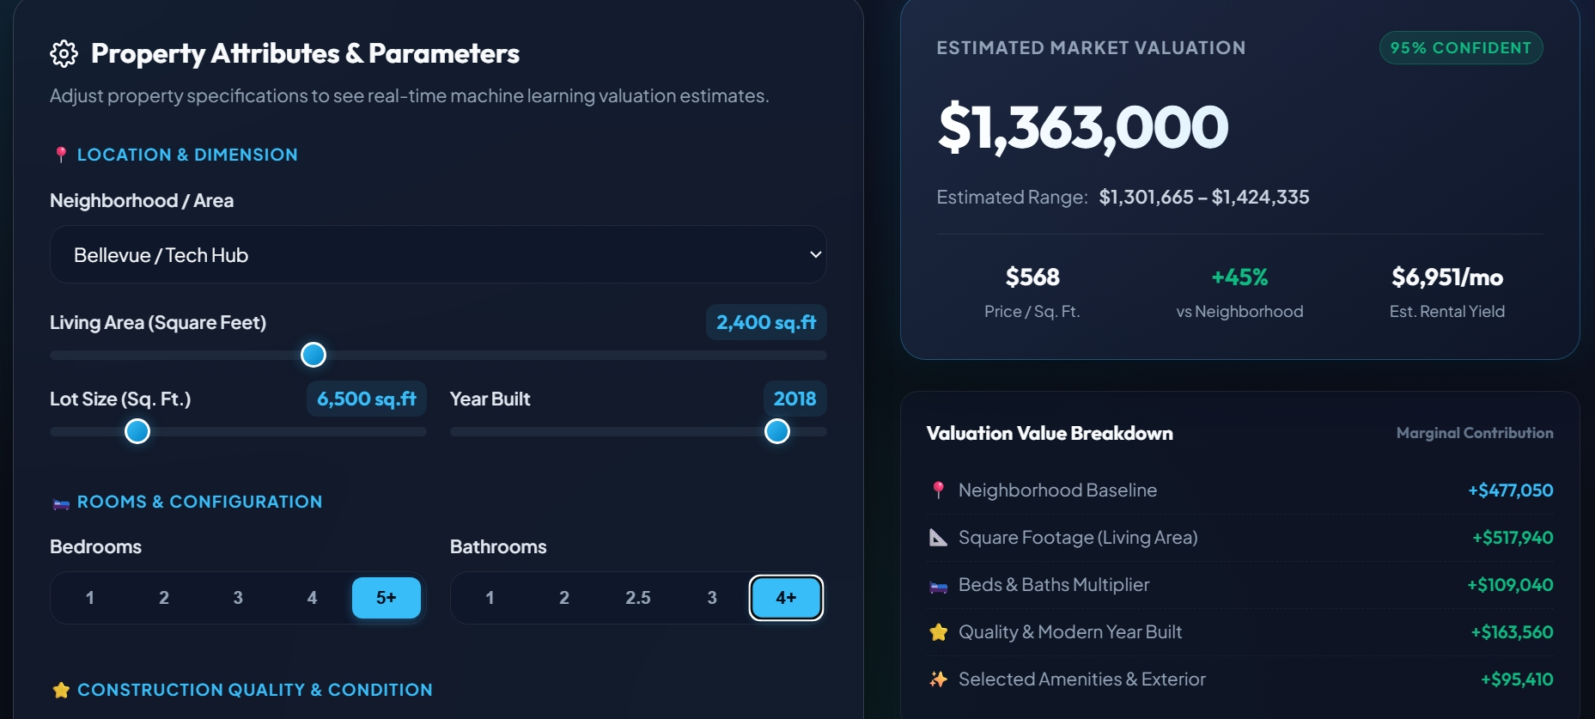
Fig 9: Step 3 — Prediction for 5+ bedrooms and 4+ bathrooms: estimated market valuation $1,363,000 (range $1,301,665 – $1,424,335)
Result:
A House Price Prediction system was successfully designed and implemented using a machine learning pipeline in Python (pandas, scikit-learn, joblib) and a web-based valuation engine (PropValuate AI). The housing data was explored, the features were encoded and split into training and testing sets, and four regression models — Linear Regression, Ridge Regression, Random Forest and Gradient Boosting — were trained and compared using MAE, RMSE and R². The Random Forest model was saved as best_housing_model.pkl and used in the web application, which achieved a model accuracy (R²) of 75.7% on the test split over 115 homes. For a 2,400 sq. ft. house in Bellevue / Tech Hub built in 2018, the estimated valuation increased from $1,114,000 (1 bedroom, 1 bathroom) to $1,185,000 (2 bed, 2 bath), $1,239,000 (3 bed, 2.5 bath), $1,293,000 (4 bed, 3 bath) and $1,363,000 (5+ bed, 4+ bath), each shown with a 95% confidence range, price per sq. ft., value breakdown and estimated monthly payment.
The estimated valuation produced by the web application for the same property (Bellevue / Tech Hub, 2,400 sq. ft. living area, 6,500 sq. ft. lot, built in 2018) for different bedroom and bathroom combinations is shown in Table 2. Every estimate is displayed with a 95% confident range.
Bed / Bath | Est. Value | Estimated Range | $ / Sq. Ft. | vs Neighborhood | Rental Yield
1 / 1 | $1,114,000 | $1,063,870 – $1,164,130 | $464 | +19% | $5,681/mo
2 / 2 | $1,185,000 | $1,131,675 – $1,238,325 | $494 | +26% | $6,044/mo
3 / 2 | $1,222,000 | $1,167,010 – $1,276,990 | $509 | +30% | $6,232/mo
3 / 2.5 | $1,239,000 | $1,183,245 – $1,294,755 | $516 | +32% | $6,319/mo
4 / 3 | $1,293,000 | $1,234,815 – $1,351,185 | $539 | +38% | $6,594/mo
5+ / 4+ | $1,363,000 | $1,301,665 – $1,424,335 | $568 | +45% | $6,951/mo
Table 2: Estimated valuation for different bedroom and bathroom combinations
The valuation value breakdown (marginal contribution) for each configuration is shown in Table 3. The neighbourhood baseline, square footage, beds & baths multiplier, quality & modern year built and the selected amenities add up to the estimated market value.
Bed / Bath | Neighborhood Baseline | Square Footage | Beds & Baths | Quality & Year Built | Amenities & Exterior
1 / 1 | $389,900 | $423,320 | $89,120 | $133,680 | $77,980
2 / 2 | $414,750 | $450,300 | $94,800 | $142,200 | $82,950
3 / 2 | $427,700 | $464,360 | $97,760 | $146,640 | $85,540
3 / 2.5 | $433,650 | $470,820 | $99,120 | $148,680 | $86,730
4 / 3 | $452,550 | $491,340 | $103,440 | $155,160 | $90,510
5+ / 4+ | $477,050 | $517,940 | $109,040 | $163,560 | $95,410
Table 3: Valuation value breakdown for each configuration

